**Ideation Phase**

**Brainstorm & Idea Prioritization Template**

Date 30 october 2023

Team ID NM2023TMID01608

Project Name Ethereum decentralised identity smart contract

Maximum Marks 4 Marks

**Brainstorm & Idea Prioritization Template:**

Develop a decentralized identity smart contract on the Ethereum blockchain that allows users to securely manage their personal information and grant selective access to authorized parties while ensuring data privacy and immutability.

Use this template in your own brainstorming sessions so your team can unleash their imagination and start shaping concepts even if you're not sitting in the same room.

Reference:https://app.mural.co/template/94238f11-00b5-42c7-8374- b3dd7c7c0b76/ae150568-42bf-46cc-b205-2f4ba1bdb4ca

**Step-1: Team Gathering, Collaboration and Select the Problem Statement**

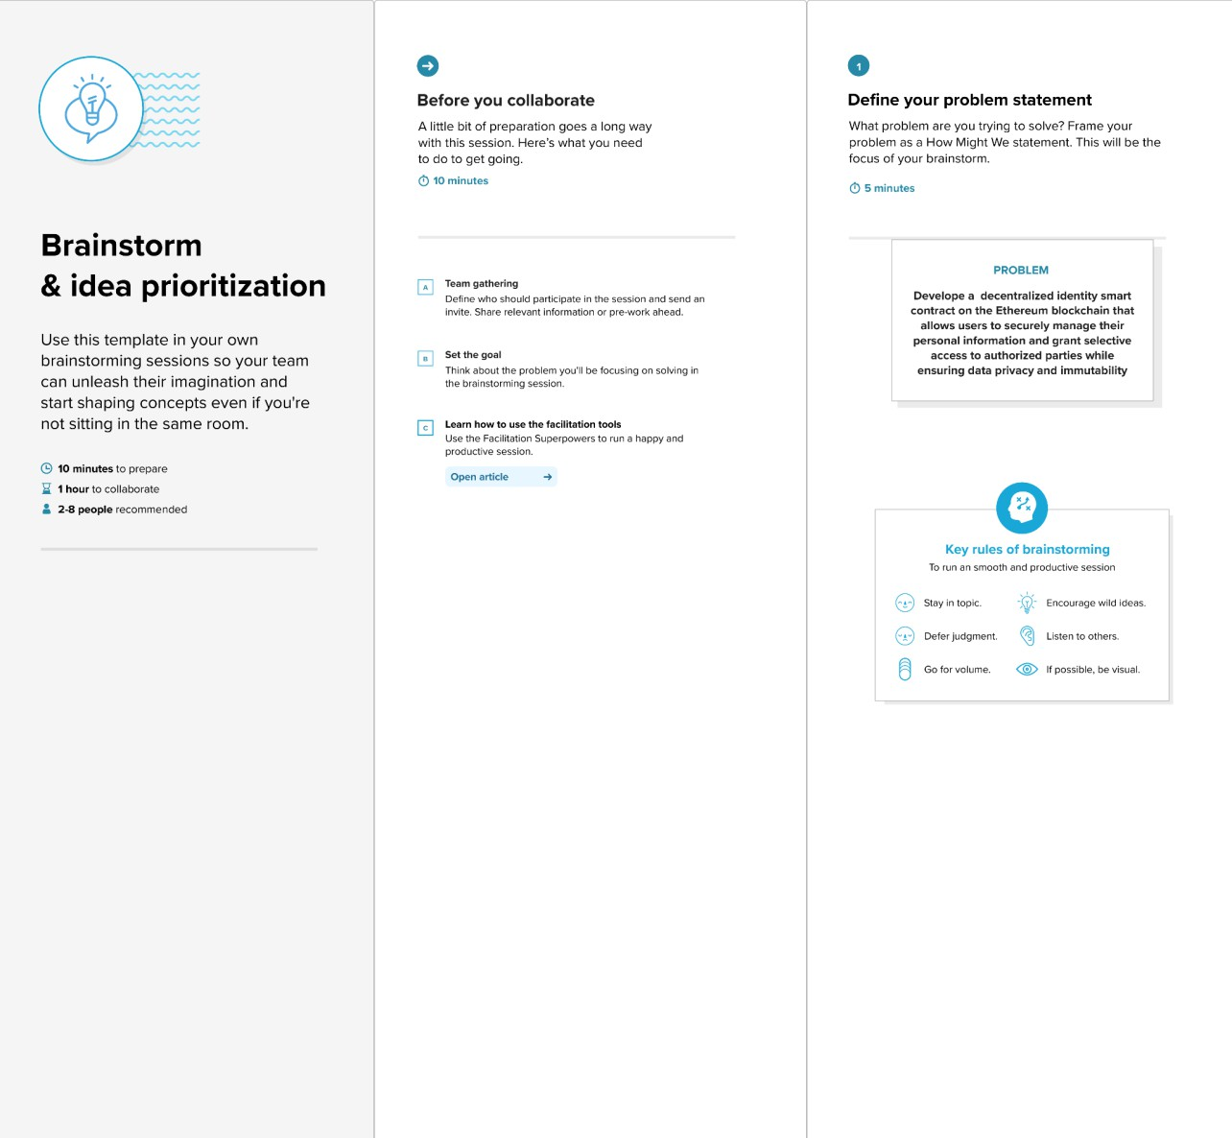

**Step-2: Brainstorm, Idea Listing and Grouping**

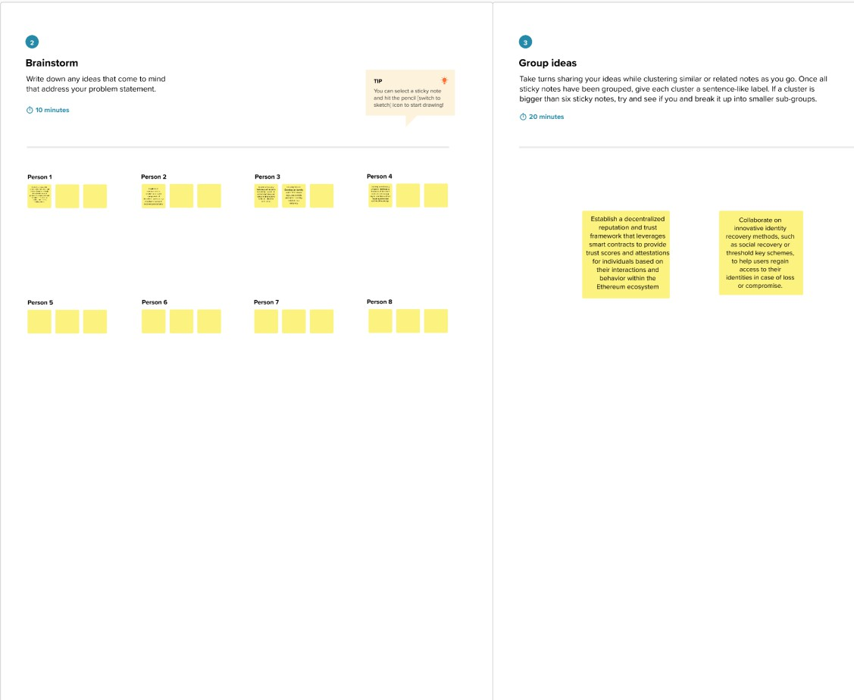

**Step-3: Idea Prioritization**

